**WEB DEVELOPMENT**

**PRACTICAL 9**

**Name:** Vrishav Garg

**Roll No.:** 12111051

**Branch:** CSE

**PRACTICAL 9:**

**CODE:**

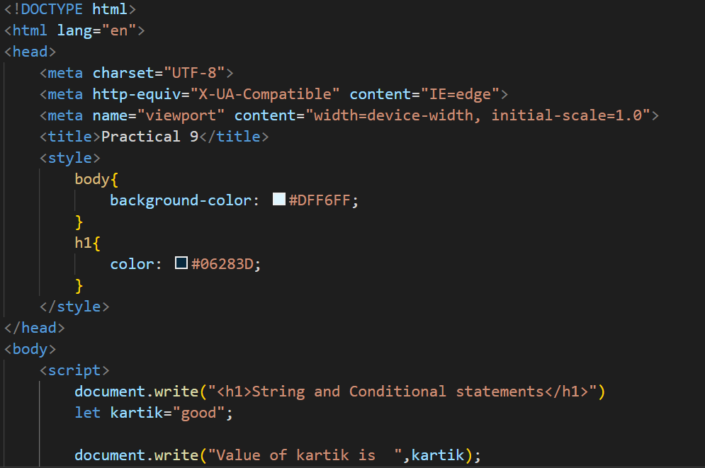

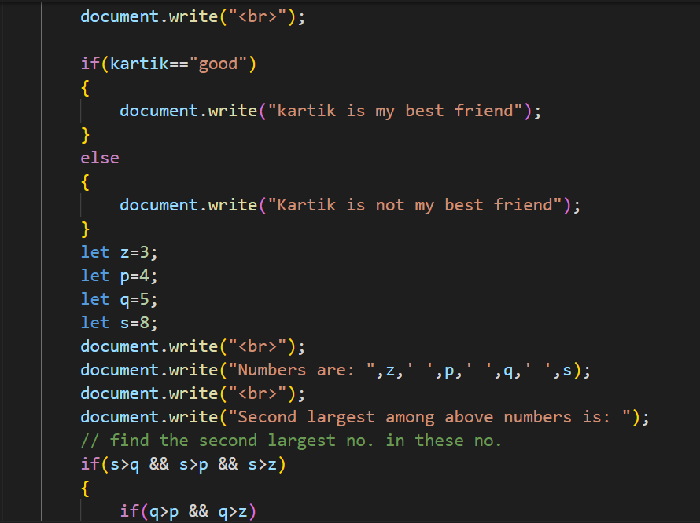

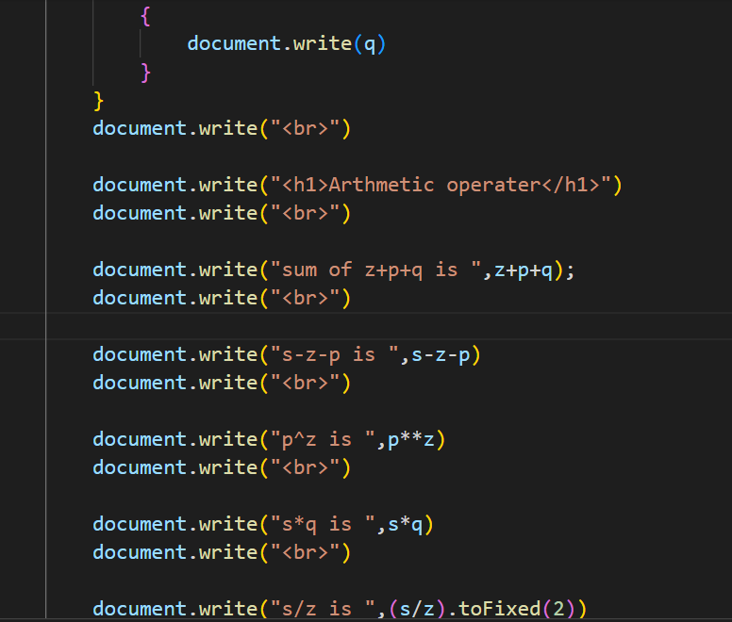

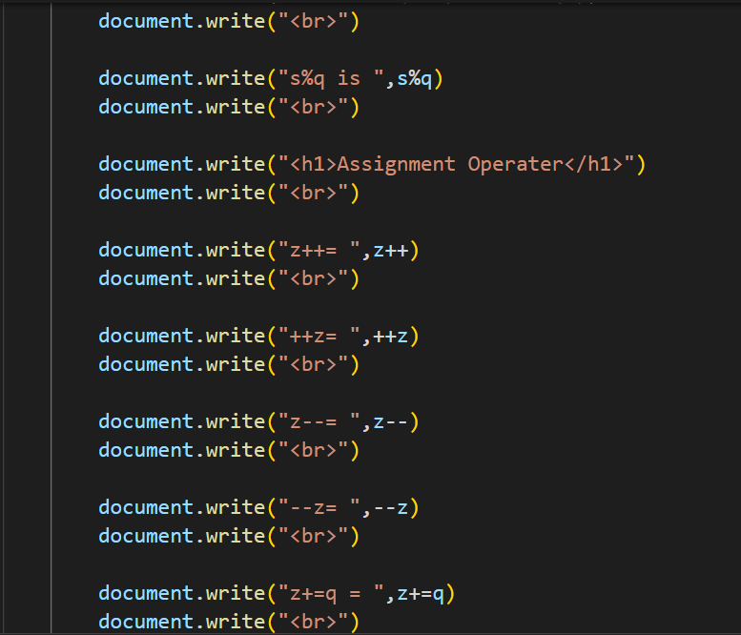

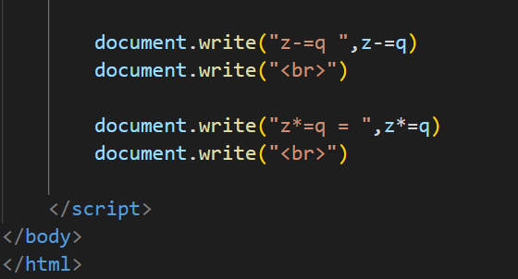

**OUTPUT:**

